Final report presented by Diana Y. 03.07.2020

**Munich or Vienna? --- which city is more suitable to you?**

**1 Introduction**

**Munich**, the third biggest city in Germany, has more than 1.5 million inhabitants and is famous for its beer, folk festival, beautiful English gardens and of course, also for its universities and a variety of businesses.

**Vienna**, the capital of Austrian, has more than 1.9 million people. It has been known for a long time that the design of Vienna is balanced and elegant. Every corner of the city tells its special story.

As young scholars, who are going to choose their first jobs after their university studies, it must be interesting and relevant to get more insights on the city life before moving there. Moreover, the question where you should set your home will be also provided with argumentative answers.

**2 Data explanation**

On the German Wikipedia website (<https://de.wikipedia.org/wiki/M%C3%BCnchen>), we can find the table on all the **25 boroughs of Munich with their areas, numbers of inhabitants and the proportion of foreigners**.

On the website (<https://de.wikipedia.org/wiki/Wien>) the table with the same structure can be easily found. We also need the website (<https://www.muenchen.de/int/en/living/postal-codes.html)> about the postal codes of Munich, because the boroughs cannot be read through Foursuqare API.

Using **Foursquare** geo data I would like to explore these two cities and get the **top 10 common venues** for each borough of the two cities.

**3 Methodology**

**3.1 Data cleaning**

Raw data from Wikipedia will be processed.

Headers will be replaced by the ones in English.

The German thousand seperator and decimal points will be transfered to make sure a correct result.

Some long borough names in German will be changed to short ones.

The final tables to further analysis is shown below:

Table 1: Munich Boroughs

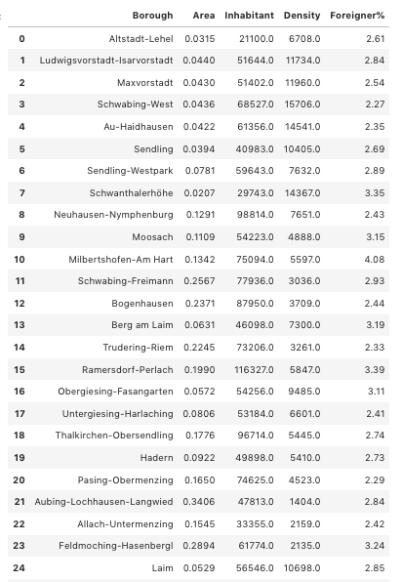

Table 2: Vienna boroughs

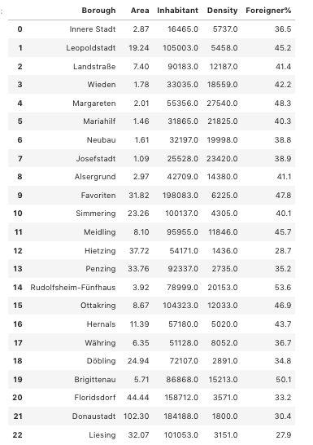

**3.2 Foursquare API**

Before using the Foursquare API, we should add the latitude and longitude coordinates of each borough to the dataframes. Then merge the dataframes. The final tables are shown below:

Table 3: Munich borough with latitude and longitude coordinates

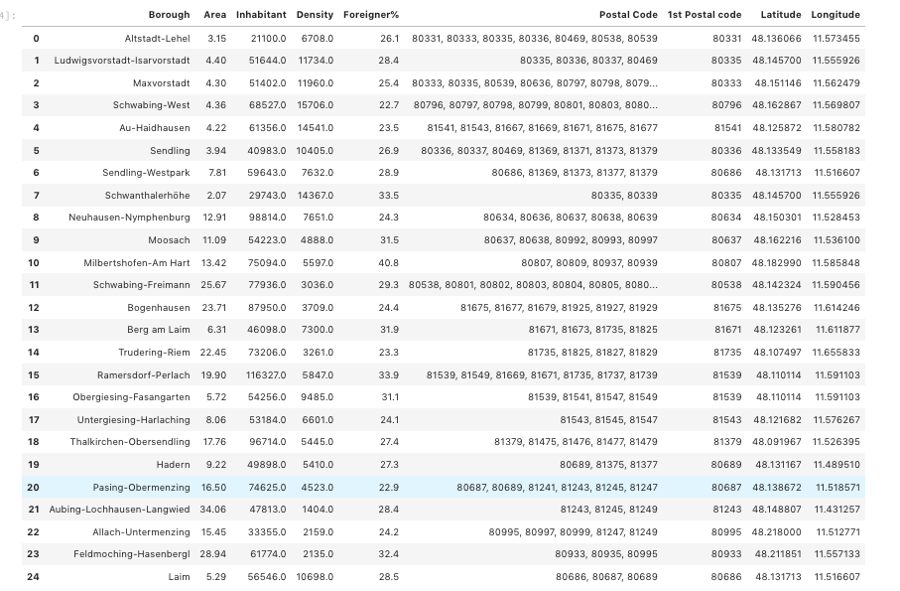

Table 4: Vienna borough with latitude and longitude coordinates

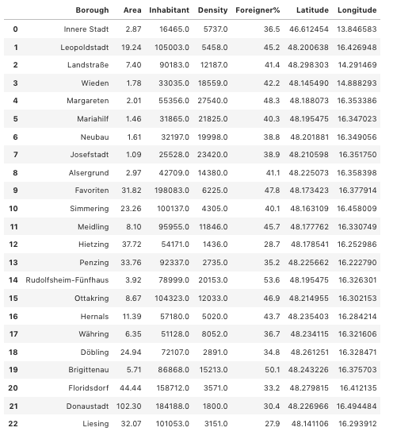

Foursquare API will be applied to get the venues in 500m of each latitude and longitude coordinates of each borough of the two cities.

The final example are shown below:

Table 5: an example of one borough with ist different kinds of venues

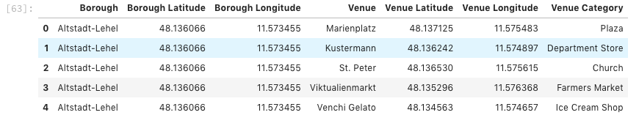

Then using onehot coding to get the frequency of every category in each borough of the two cities. The final example are shown below

Table 6: frequency table of venue categories for each borough

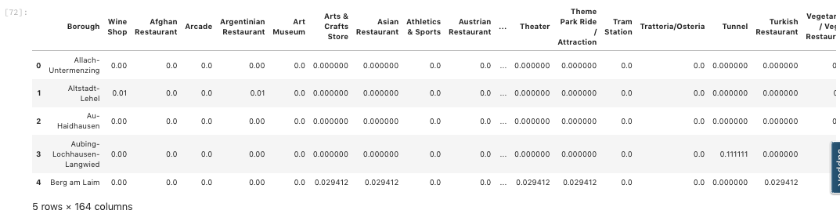

According to the frequency table, get the 10 most common venues for each borough

Table 7: 10 most common venues for each borough

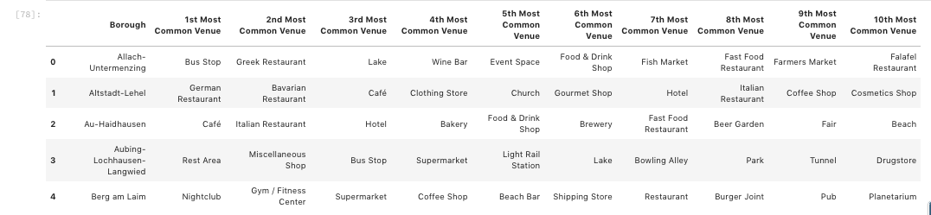

**3.3 KMeans Clustering**

We get 163 venue categories for Munich and 145 for Vienna .

Taking „density“ and „proportion of inhabitants with immigration background“ into considertation, we get the table shown below to perform a Kmeans Clustering.

The boroughs of the two cities will be divided into 5 groups.

Table 8: Table for KMeans Clustering

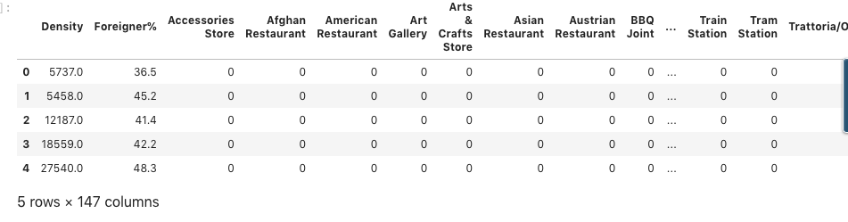

**4 Results**

Photo 1: map of Munich

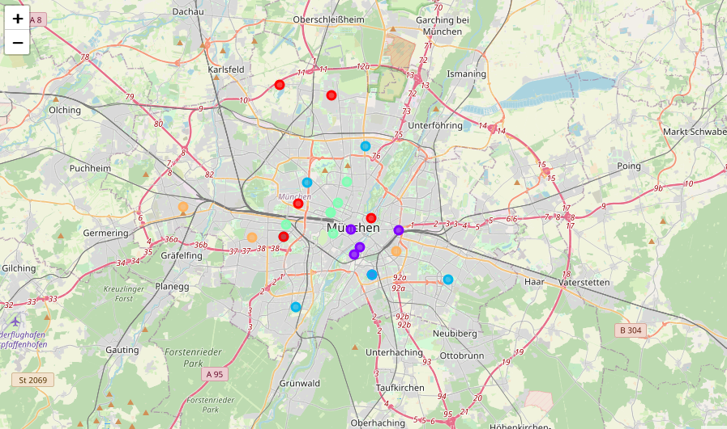

Photo 2: map of Vienna

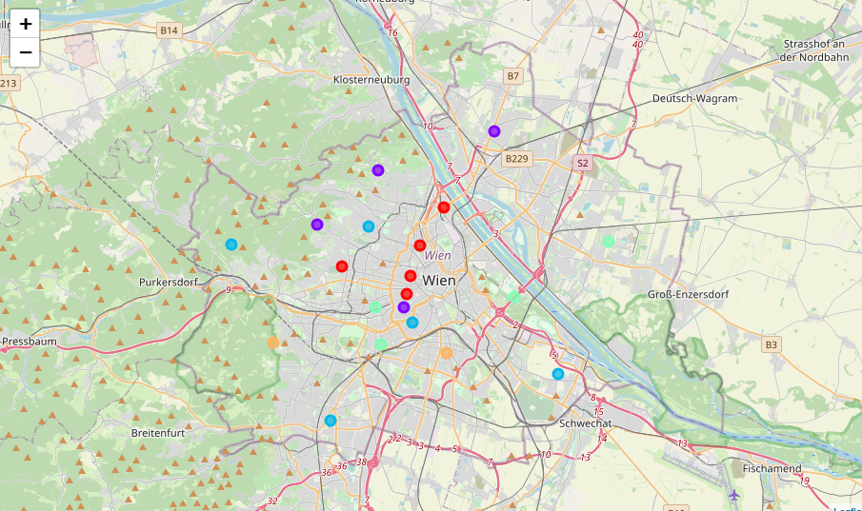

Munich's 25 boroughs has 163 categories of common venues, while Vienna's 23 boroughs has 145.

Munich: we have devided the 25 boroughs of Munich into five groups, according to their common venues and also the densities and the proportions of foreigners.

We can see that the boroughs in the city center(Ludwigsvorstadt-Isarvorstadt,Maxvorstadt, Schwabing-West, Sendling, Schwanthalerhöhe) and the new center of the satellite city (Pasing-Obermenzing) are in the same group. These regions (except the new Pasing center) have a very high density (>10000 people pro km2)and a relatively low proportion of foreigners (5 of 6 <30%). A great diversity of restaurants and cafes compose the most 10 common venues. (green spots in the Muc-Map)

Milbershofen-Am-Hart, Moosach, Thalkirchen-Obersendling, Truding and Obergiesing (blue spots in the MUC-Map) are around the suburb region of Munich, the density of the regions are relativly high, and because of the high proportion of foreigners, Milbershofen may be the most multicultural borough of Munich. The common venues are not fancy international restaurants, but local drink and food shops and some supermarkets, cafes and public transportation stops.

Altstadt-Lehel is the traditional old town of Munich, Bogenhausen, Auhaidhausen and Untergiesing are tightly around Lehel. With relatively low density and low proportion of international inhabitants, the regions are known for its bourgeois style: shopping mal, fancy gourmet shops, wine shops, parks and public squares.(Puple points in the MUC-Map)

Laim, Schwabing-Freimann and Nymphenburg plus Allach-Untermenzing and Feldmoching are in the same group, which surprises me not a few. The first three boroughs are between the city center and suburb regions of Munich. Laim has the highest density (>10000) because many companies are landed in Laim. The last two boroughs are some farther from the city center and have common venues for everyday life. (Red points in the MUC-Map)

The last group is composed of Hadern, Berg-am-Laim and Aubing, which are in the middle of the broad Munich area. Besides venues for everyday life, in Berg-am-Laim, people can also easily find nightclubs and fitness studios. (Orange spot in MUC-Map)

Vienna : Vienna's boroughs can also be divided in 5 groups.

Neubau, Josephsstadt, Alsergrund, Briggitenau, Ottakring constitute the city center of Vienna. A very high density (>12000 people/km2) and proportion of international inhabitants (>38%). Fancy restaurants, winery,farmer markets, event places are around every corner. (red spots in the Vienna-Map)

Mariahilf, which has the highest density, and Hernals, Floridsdorf, Döbling, whose density is moderate, are in the second group. The common venues are quite similar to the last group and Asian restaurants are more easily to find here. (purple spots in the Vienna-Map)

Liesing, Penzing, Sommering, Währing are the surburb regions of Vienna; Margaretten, Landsstr. and Wieden still belong to the center of Vienna. So I am suprised about this group. The density of the last three is quite high (>12000), and the first three are quite low (around 4000). But according to the common venues there are quite the same. (blue spots in the Vienna-Map)

Innere Stadt, Leopoldstr. Meidling, Donaustadt and Rudolfsheim are in the same group. Rudolfsheim is tightly around the city center and has a very high density (>20000) and Multiplex is its most common venue. (green spots in the Vienna-Map)

Hietzing and Favoriten constitute the final group. They are in the suburb of the Vienna city. In Favoriten, hotels will be the easiest venue to find, and in Hietzing, steakhouse and French restaurants are the most common venue, despite its lowest density and proportion of international inhabitants among all the boroughs in Vienna. (orange spots in the Vienna-Map)

5 Discussions

The analysis using KMeans has still much room to improve. Only according to the common venues, we can only get a rough profile of the boroughs in the two cities. With the density and the proportion of international inhabitants, the big picture can be depicted, but for a finer picture, we need to take other relavant parameters into account, such as the average real estate price in each borough of the two cities, which will influence the results emormously.

Moreover, the categories got through the Foursquare API are quite detailed. A factor analysis to reduce dimensions is also quite necessary to know the boroughs better.

6 Conclusion

To sum up, in the city center of Munich, the huge diversity of restaurants is quite noticeable. Parks and public squares decorate its superior residential area. International inhabitants in Munich usually don't live in the city center, but in the north part of city, while in Vienna, the situation is oppisite. Overall, the proportion of foreigners in Vienna is around 10% higher than Munich. Moreover, the city center of Vienna is double crowed than that of Munich. In Vienna, the kinds of restaurants are less than those in Munich, but you can find more event places, winery and farmer markets.

So if you are a young scholar with great interest in gourmet and supreme life style, the center of Munich may be a better choice. And if you are a young international scholar,in the city center of Vienna you may find people with different culture more easily.